0. Introduction V. 3.2

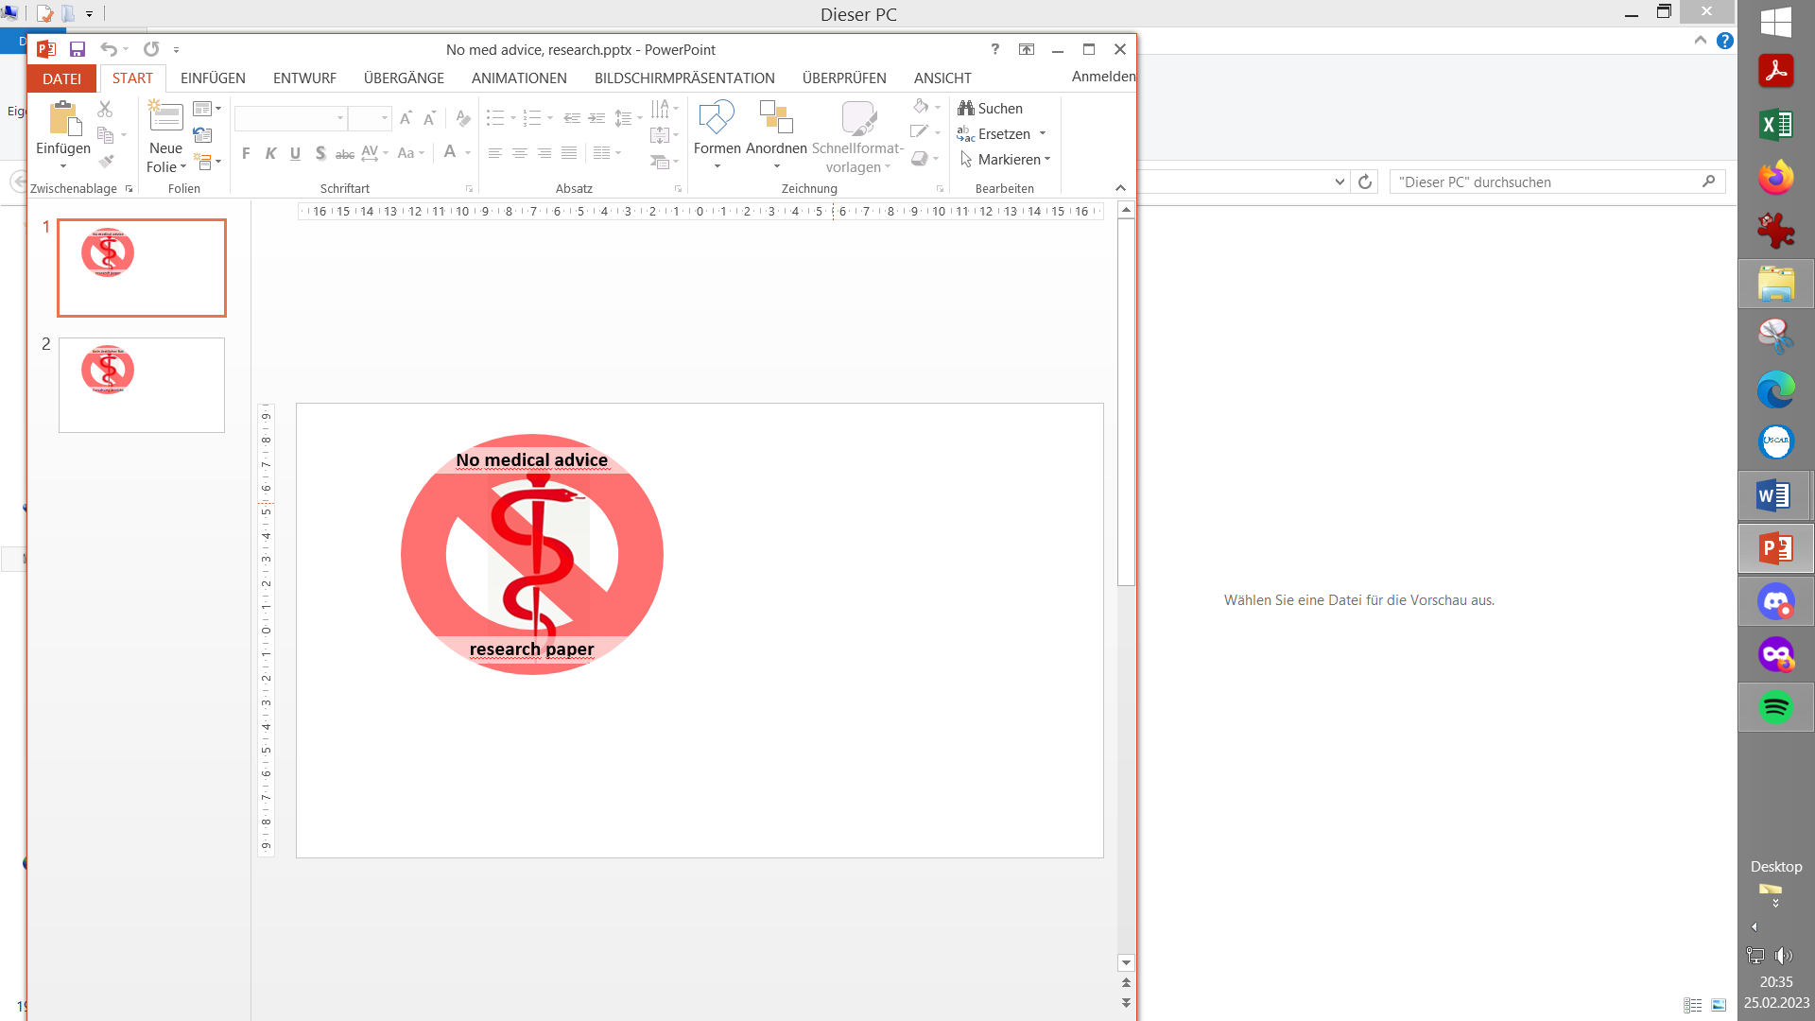

Exploring Full Closed Loop potential of-autoISF *(=*

Disclaimer – Important to read and understand

Authors are no medical professionals but T1 diabetics (or parents of a T1D child) who report their -limited - understanding and experience, in an effort to contribute to a growing body of knowledge, and to facilitate development of patient centered solutions.

**Nothing in this site is medical advice**, but meant to stimulate patient-driven self-responsible research, and is meant also to stimulate product developments by the medical industry. Anything you try to conclude for yourself you do on own risk. **This is by no means a medical product but what is offered is a toolset for participating in development.**

Never copy what others report to use, but **investigate and adjust to your data**. Neglecting safety instructions, and just using the “buttons” that are made available in a supposed “learning by doing” mode, would be very dangerous with the early development stage tools this research paper is about.

In case you choose to get deeper involved, **run the system disconnected**, parallel to your current glucose management, to learn its behavior before eventually considering (on own risk) to go any further. Please stay connected and share experiences, too.

Introduction

**Full Closed Loop using Automations** is represented in AAPS Master and in the related readthedocs since autumn 2023. (<https://androidaps.readthedocs.io/en/latest/Usage/FullClosedLoop.html>. ).

Pre-requisites and the principal function of a Full Closed Loop, without the user ever giving a bolus and without entering any carb info are explained, also in a couple of other languages, there (and also in our section 1.)

**autoISF** is being developed as a much more **sophisticated** **alternative for FCL, aiming at higher %TIR performance and/or higher degree of daily „freedom“** than simpler approaches to FCL could provide.

However, this demands much higher degree of involvement by the user. **Setting up your FCL is a very serious multi-week project, and it is important that you follow us through the material in the sequence of suggested steps**.

With autoISF, and especially with the intention to use it for Full Closed Loop, you are in the early development area. It is therefore important to observe the disclaimer given above, and the warnings given in the e-book sections, as well as the hints given by the developers in the respective manuals and readme files on their Github pages:

* For autoISF with **AAPS,** the main ones are <https://github.com/ga-zelle/autoISF/> and <https://github.com/T-o-b-i-a-s/AndroidAPS/tree/3.2.0.4-ai3.0.1>

That version was in very minor ways updated in beginning of 2025:

* AAPS3.2.0.4-ai3.0.1_no-version-check is offered to eliminate the update request to Master AAPS 3.3. (It will take many months to transform all autoISF code for AAPS 3.3; and “negotiations” might not lead to acceptance of all features in Master).
* AAPS3.2.0.4-ai3.0.2 offers a tiny bit more re. info about iobTH in the SMB tab

**This e-book is valid for all these versions**. Should you choose to upgrade to AAPS 3.3 (Master or dev) you also get (some or many) autoISF features - but not all. and so this e-book will not fully apply (notably not sections 3.4 and 6.6)

* Note there is **no** comparable FCL solution for **iOS Loop** because their algorithm depends very much on carb inputs.
* However, theoref(1) algorithm (UAM+SMB as in AAPS) has been developed also for **i-Phone** based systems:
  + on the **Trio** platform <https://discord.gg/Rr37aAzWz9>, “**TAI**” (for Trio + autoISF) dev variant with autoISF see https://github.com/mountrcg/Trio#autoisf
  + on the **iAPS** platform, with autoISF ported into rapidly evolving early development branches of iAPS: [https://github.com/mountrcg/iAPS /](https://github.com/mountrcg/iAPS%20/) readme.md. dev_autoISF3.x_newUI is the default branch there for autoISF.

Note that setting up an autoISF FCL on i-Phone platform may be especially hard.iAPS/Trio users are disadvantaged vs AAPS because 1) lack of some technical features (Automations, emulator) 2) there is no e-book variant exactly for their system 3) many users did not go through the mandatory “education” via Objectives as in AAPS, and might not have a good “vanilla HCL” starting point (“blueprint for your FCL”, as I call it in section 4.1)

Unless you are ready to do a lot of reading and loop data analysis to get your FCL running, please stay away. Trial and error won’t get you far: Yes; with 18 (!) additional parameters on bord, you always can “trick” your loop to get one situation (e.g. pizza) look pretty good. But to find settings that cover also other situations well (say, a salad with chicken) is not easy. It is possible, though, if you “build” your FCL following the suggestions, notably in sections 2 and 4).

If you currently can’t commit yourself, or lack an important pre-requisite, you might want to consider one of the following “easier” options:

* You could first try the **Full Closed Loop in a simpler form** with Automations (see AAPS readthedocs and section 13.1):

Depending on the quality of their HCL tuning they are starting from, their expectations for %TIR, and on rapid carb contents of their diet, an increasing number of people succeed in making a respectable start the first time they try using AAPS in that much simpler Full Closed Loop mode.

See also the first published medical study that included 16 patients using AAPS, who found, on average, comparable %TIR performance when using a basic Full Closed Loop mode: <https://pubmed.ncbi.nlm.nih.gov/36826996/>

Note that Trio and iAPS lack Automations, This makes it much more complicated if you try similar implementations via so-called middleware.

* You could also opt for a **Meal Announcement** method, which is a significant step from HCL *towards* FCL, but still **involves a** **pre-bolus**.
  + For autoISF, this method is sketched in section 7.
  + Other early-DEV-variants of AAPS are mentioned in section 13.3, which also undergo permanent further development (Boost, AIMI, EatingNow, Tsunami).
  + AIMI was also ported into Trio as an option, see <https://github.com/mountrcg/Trio#aimi-b30>

Note that all these “Meal Announcement” methods are far less well described than the two FCL options, but they are easier to set up and give some of the benefits you may seek (notably, no carb counting).